INFO 630 - Assignment 1

Section 001 - Yiyun Zhang - April.19 2020

Due Date: See syllabus

1. [10 Points]
A software project has been estimated to cost $1,200,000 and take 14 months. Given the average project outcomes from the Standish Group’s CHAOS report discussed at the beginning of Chapter 1 in the text, if the project completes at all what will its actual cost and schedule more likely turn out to be?

According to the Standish Group’s CHAOS report, the data is 45% over budget, 63% over schedule. So the actual cost is $1,200,000 * 1.45 = $1,740,000 and actually take 14 months * 1.63 = 22.82 months.

2. [ 10 Points]
Answer Self-study Question #4 of Chapter 1 (page 11) of the textbook.

The Expeditionary Combat Support System (ECSS) was a net money loser for the United States Air Force. The organization was the United States Air Force. The project was Expeditionary Combat Support System (ECSS). It happened between 2005 and 2012. There were $1.1 billion spent on the project and required additional $1.1 billion to continue and field. The software project did not recover, it was failed and canceled.

References:
Kanaracus, Chris (14 November 2012). "Air Force scraps massive ERP project after racking up $1B in costs". Computerworld. April 15, 2020.
Shalal-Esa, Andrea (5 December 2012). "US senators question Pentagon on $1 bln canceled program". Reuters. April 15, 2020.
"$1 billion wasted on the Air Force computer system". NBC Nightly News. 8 February 2013. April 15, 2020.

3. [10 Points]
Assume that Zymurgenics, Inc. had gross revenues of $22,500,000 last year. Various costs for labor, material, operating expenses, etc. totaled $20,150,000. Income taxes amounted to $822,500. What was their actual profit for the year? What was their profit margin?

The actual profit is $22,500,000 - $20,150,000 - $822,500 = $1,527,500, their profit margin is $1,527,500 / $22,500,000 = 0.0679 = 6.79%

4. [10 Points]
Answer Self-study Question #2 in Chapter 2 (page 21) of the textbook.
Note: You can access most public company finanical by their website.

Since I am not currently employed, I am using Alphabet company’s 2019 Q4 report. The sources of gross revenue are: Google Search & other, YouTube ads, Google properties, Google Network Members' properties, Google advertising, Google Cloud, Google other, Google revenues, Other Bets revenues and Hedging gains (losses).

Reference:
“Alphabet Announces First Quarter 2019 Results”, Alphabet Inc. February 3, 2020. April 15, 2020. https://abc.xyz/investor/static/pdf/2019Q4_alphabet_earnings_release.pdf?cache=79552b8

5. [10 Points]
Answer Self-study Question #5 in Chapter 2 (page 21) of the textbook.

Base on Alphabet company’s 2019 Q4 report, the cost category and spent money is:
Cost of revenues: $21,020 million
Research and development: $7,222 million
Sales and marketing: $5,738 million
General and administrative: $2,829 million
European Commission fines: $0 million
Provision for income taxes: $33 million

Reference:
“Alphabet Announces First Quarter 2019 Results”, Alphabet Inc. February 3, 2020. April 15, 2020. https://abc.xyz/investor/static/pdf/2019Q4_alphabet_earnings_release.pdf?cache=79552b8

6. [10 Points]
If you are currently working on a software project team, estimate the total number of person-years that will be spent to complete that project. State that estimate as part of your answer to this question. If you are not currently working on a software project team, or cannot estimate the total labor of your project, assume a labor estimate of 12.5 person-years. Calculate the labor cost of the estimated project using an FTE rate of $185,000 per year.

The labor cost will be $185,000 * 12.5 = $2,312,500

7. [10 Points]
Name at least one situation, other than what was already identified in the text or in class, where the concepts and techniques in this book would be useful in helping you make important decisions about your own personal finances.

I think the concept of the role of a technical person in a not-for-profit company, in other words, the technique of providing the greatest benefit at the least cost, is very useful and enlightening for me. As a programmer, I think I will definitely work on some side projects when I am off work. In this circumstance, without the company's resources and support, I should choose the least cost tools to achieve my goal such as open source softwares, to provide the greatest benefit or solve the problem effectively. By using this technique, those side projects will not put my personal finances on risk and it is obviously an effective way to maximize my profit.

8. [10 Points]
Answer Self-study Question #2 in Chapter 3 (page 33) of the textbook.

Initial Investment: Buy server hardware, hire or train developers, buy development environment and tools, etc.
Operation and Maintenance Cost: Server operation and maintenance needs money, such as electricity, operators salary, etc.
Sales Income: Income from pick-up delivery service. Possible income from selling this software on market.
Cost Avoidance: Use open source softwares. Put this software on market and for sale.
Salvage Value: Development environment and tools, server hardware.

9. [10 Points]
Answer Self-study Question #3 in Chapter 3 (page 33) of the textbook..

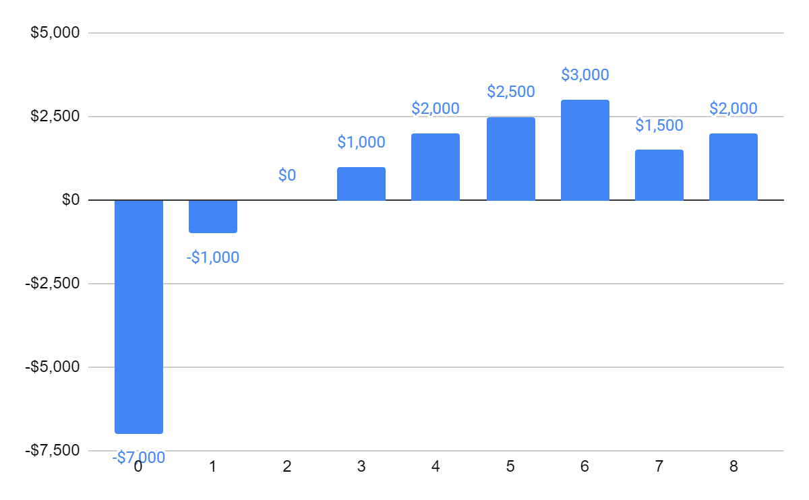

10. [10 Points]
Draw the net cash flow diagram for the following situation.

Year | Income | Expenses
0 | $0 | $5000
1 | $0 | $2000
2 | $1500 | $1200
3 | $2700 | $1200
4 | $3300 | $2000
5 | $5500 | $2500
6 | $6800 | $3000
7 | $4300 | $1500
8 | $2800 | $0

